Program 7: Working with Gradle – Creating a Gradle Project, Understanding the Build File

Procedure
Step 1: Create a Gradle Project Folder
Open the terminal and create a new project folder named MyGradleApp inside the DevOps directory:
cd ~/devops
mkdir MyGradleApp
cd MyGradleApp
Step 2: Initialize the Project using gradle init
gradle init --type java-application
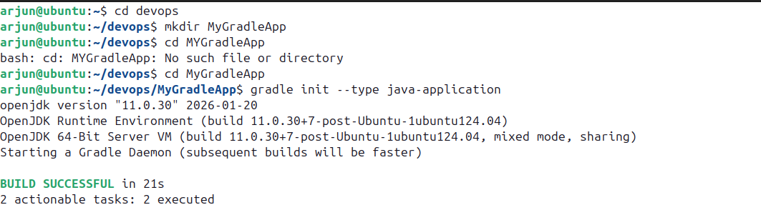

Step 3: Navigate to the Project Directory
cd MyGradleApp
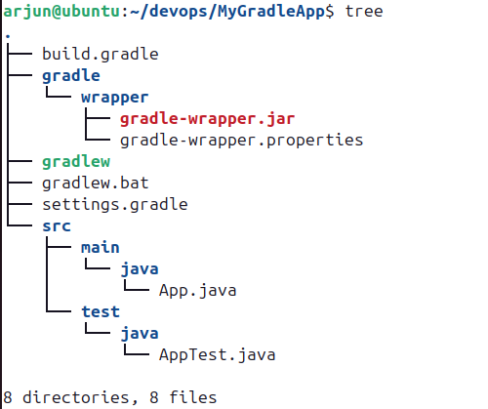
tree

Step 4: Build the Project
gradle build
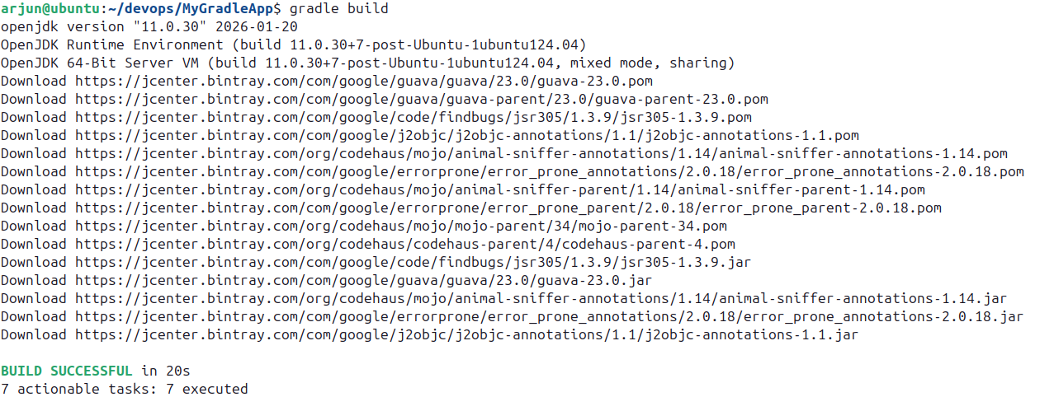

Step 5: Run the Application
gradle run
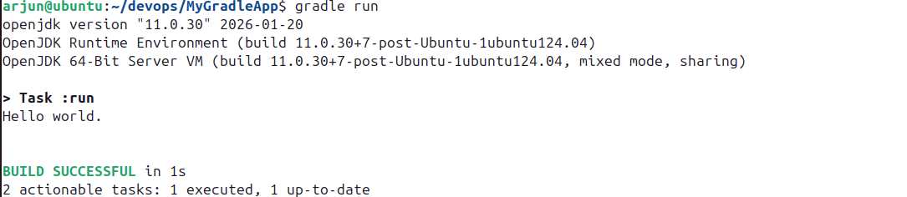
Step 6: Open and Edit build.gradle
gedit build.gradle
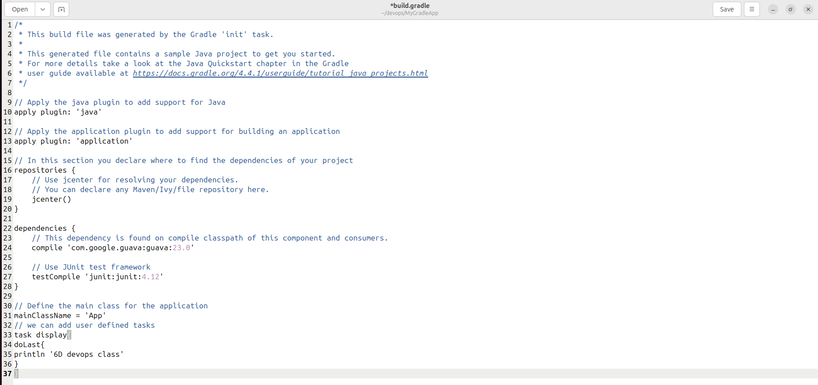

Step 7: Run the Custom Task
gradle display

